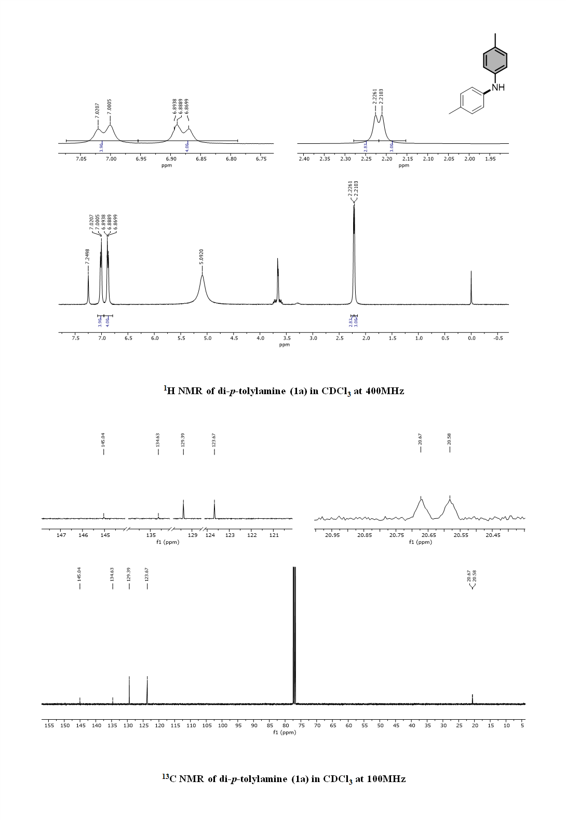
Figure 1 ¹H NMR and ¹³CNMR of di-p-tolylamine (1a) in CDCl3 at 400 MHz

Figure 2 ¹H NMR and ¹³C NMR of 4-(p-tolylamino)benzonitrile (1b) in CDCl₃ at 400 MHz

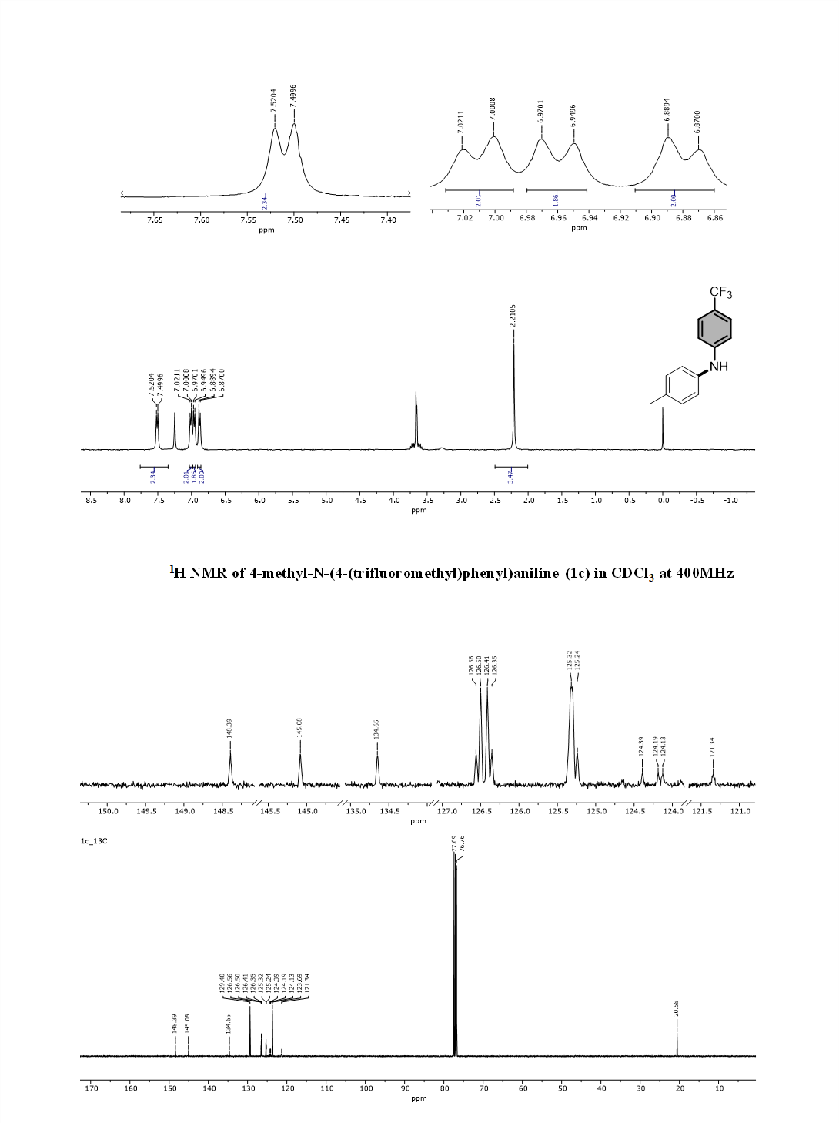
Figure 3 ¹H NMR and ¹³C NMR of 4-methyl-N-(4-(trifluoromethyl) phenyl) aniline (1c) in CDCl₃ at 400 MHz

Figure 4 ¹H NMR and ¹³C NMR of 4-methyl-N-(4-nitrophenyl) aniline (1d) in CDCl₃ at 400 MHz
Figure 5 ¹H NMR and ¹³C NMR of 3-methyl-N-phenylaniline (1e) in CDCl₃ at 400 MHz

Figure 6 ¹H NMR and ¹³C NMR of 3-methyl-N-phenylaniline (1f) in CDCl₃ at 400 MHz
Figure 7 ¹H NMR and ¹³C NMR of N-(4-methoxyphenyl)-3-methylaniline (1g), in CDCl₃ at 400 MHz
Figure 8 ¹H NMR and ¹³C NMR of 3-methyl-N-(4-(trifluoromethyl) phenyl) aniline (1h) in CDCl₃ at 400 MHz
Figure 9 ¹H NMR and ¹³C NMR of 4-(m- tolyl amino) benzonitrile (1i) in CDCl₃ at 400 MHz
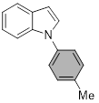
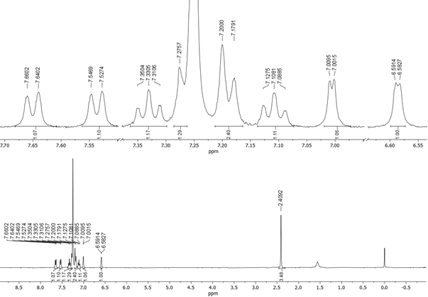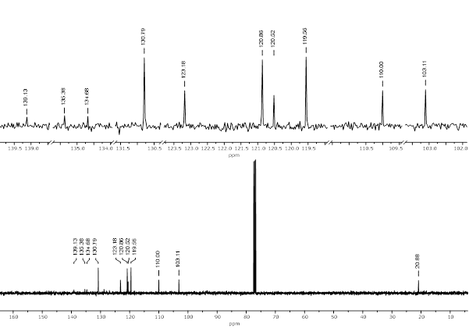
Figure 10 ¹H NMR and ¹³C NMR of 1-(p-tolyl)-1H-indole (1j) in CDCl₃ at 400 MHz
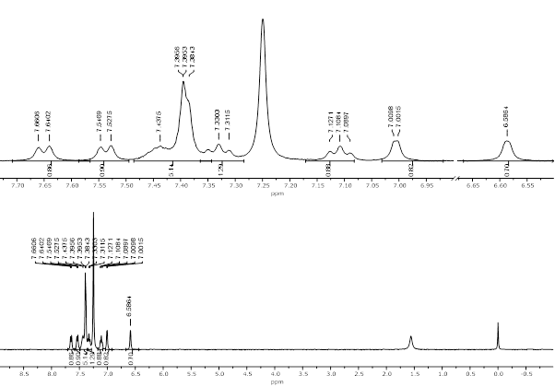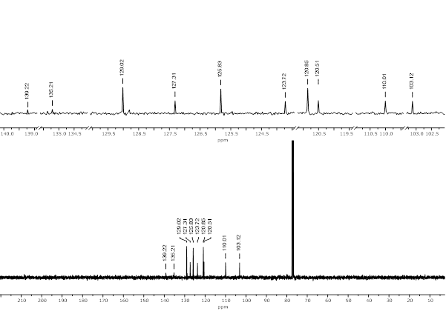
Figure 11 ¹H NMR and ¹³C NMR of 1-phenyl-1H-indole (1k) in CDCl₃ at 400 MHz

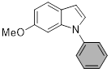
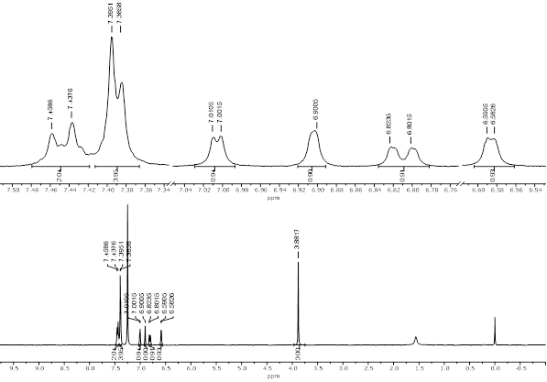
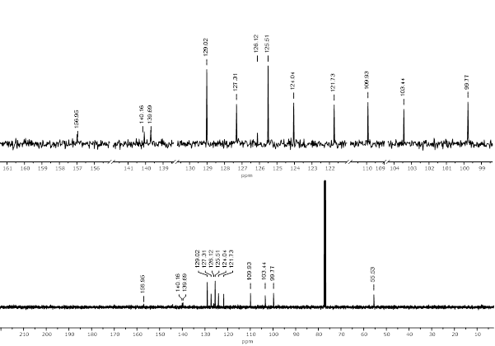
Figure 12 ¹H NMR and ¹³C NMR of 6-methoxy-1-phenyl-1H-indole (1l) in CDCl₃ at 400 MHz
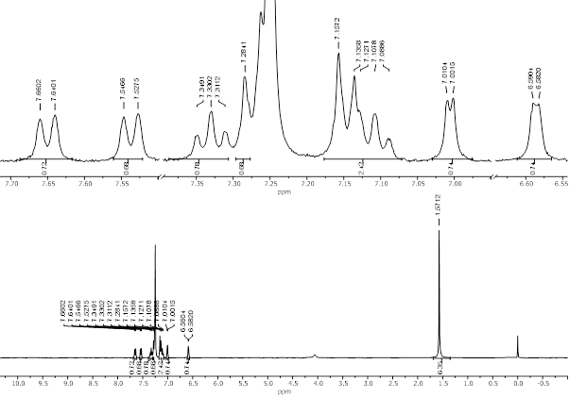
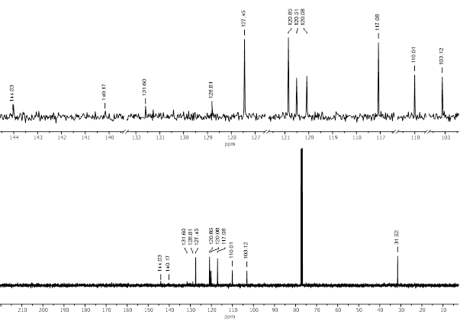
Figure 13 ¹H NMR and ¹³C NMR 2-(4-(1H-indol-1-yl)phenyl)propan-2-ol (1m) in CDCl₃ at 400 MHz
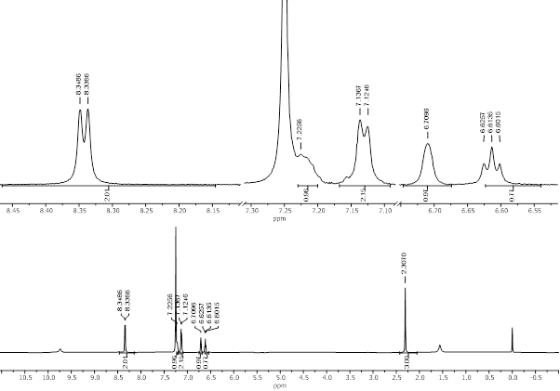
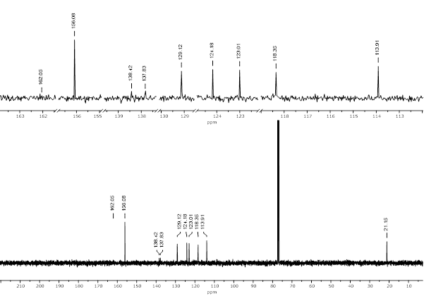
Figure 14 ¹H NMR and ¹³C NMR N-(m-tolyl) pyrimidin-2-amine (1n) in CDCl₃ at 400 MHz
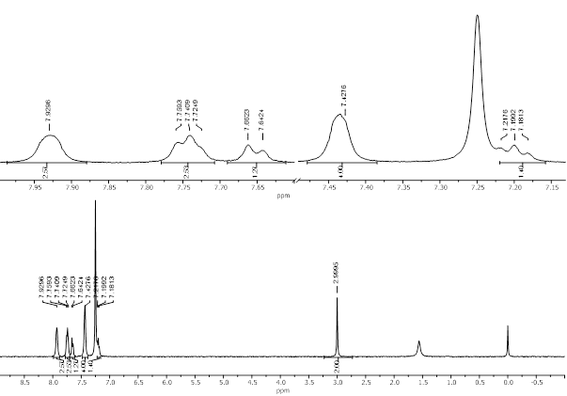
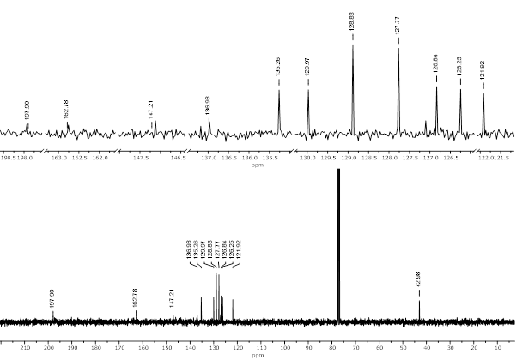
Figure 15 ¹H NMR and ¹³C NMR of 2-phenylquinolin-4(3H)-one (1o) in CDCl₃ at 400 MHz
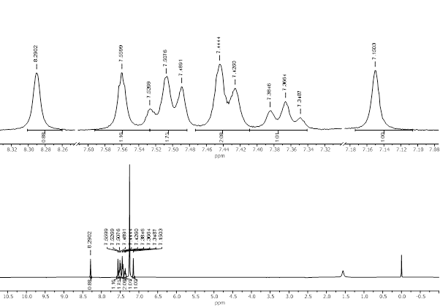
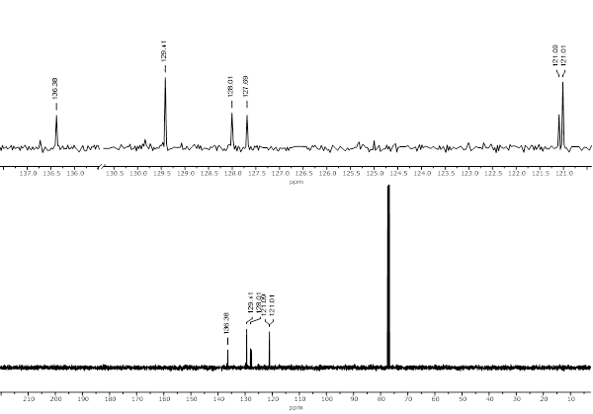
Figure 16 ¹H NMR and ¹³C NMR of 1-phenyl-1H-imidazole (1p) in CDCl₃ at 400 MHz
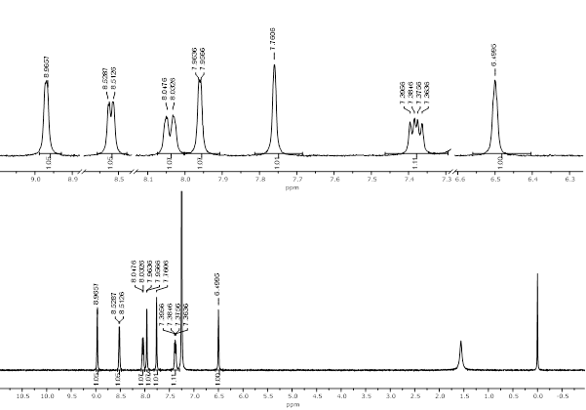
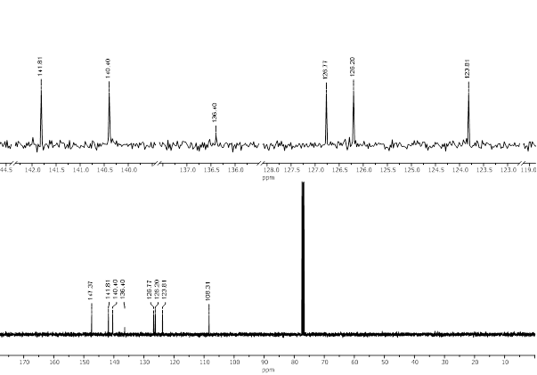
Figure 17 ¹H NMR and ¹³C NMR of 3-(1H-pyrazol-1-yl) pyridine (1q) in CDCl₃ at 400 MHz
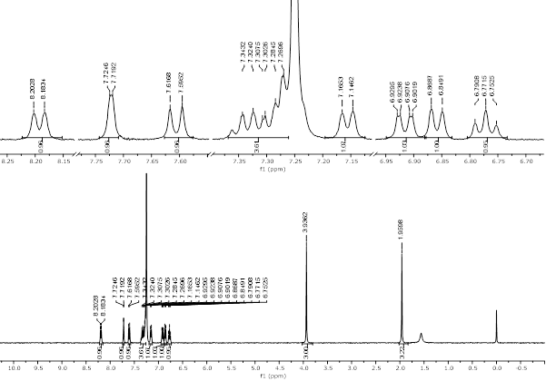
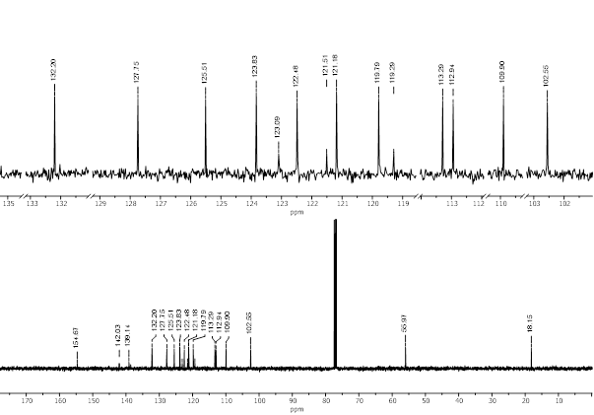
Figure 18 ¹H NMR and ¹³C NMR of 3-methoxy-9-(o-tolyl)-9H-carbazole (1r) in CDCl₃ at 400 MHz
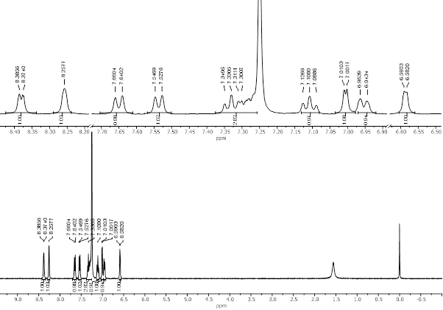
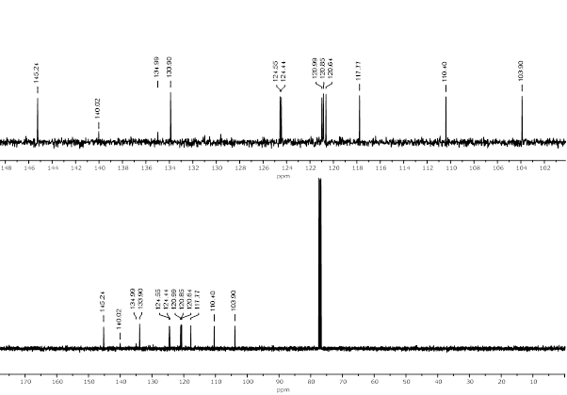
Figure 19 ¹H NMR and ¹³C NMR of 1-(pyridin-3-yl)-1H-indole (1s) in CDCl₃ at 400 MHz
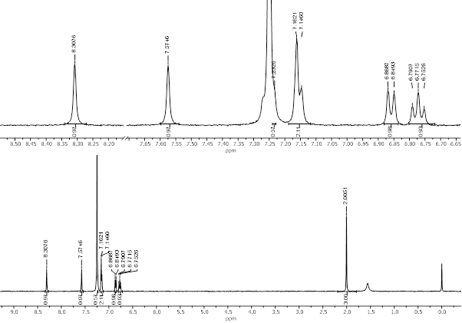
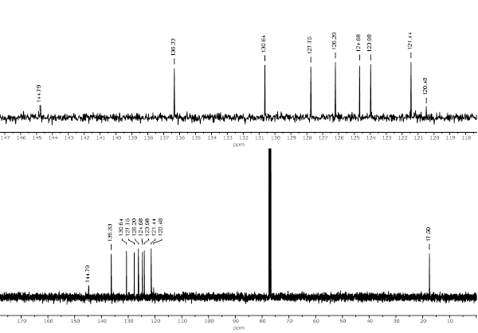
Figure 20 ¹H NMR and ¹³C NMR of 1-(o-tolyl)-1H-imidazole (1t) in DMSO-d ₆ at 400 MHz
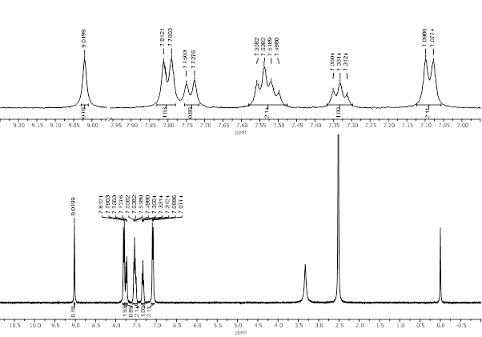
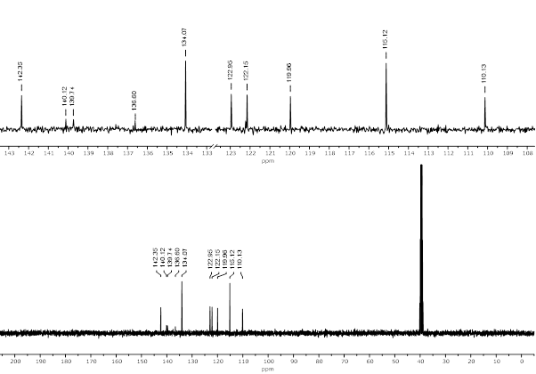
Figure 21 ¹H NMR and ¹³C NMR of 4-(1H-benzo[d]imidazol-1-yl)benzonitrile(1u) in DMSO-d ₆ at 400 MHz

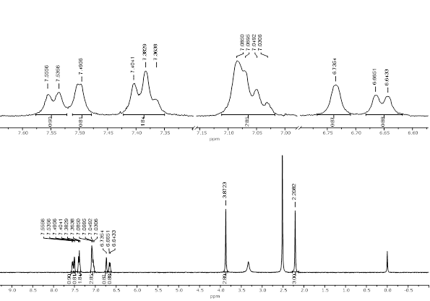
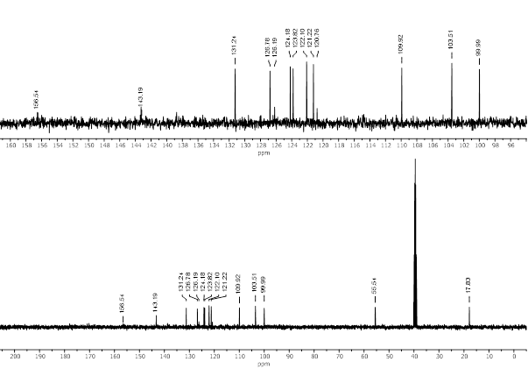
Figure 22 ¹H NMR and ¹³C NMR of 6-methoxy-1-(o-tolyl)-1H-indole (1v) in DMSO-d₆ at 400 MHz
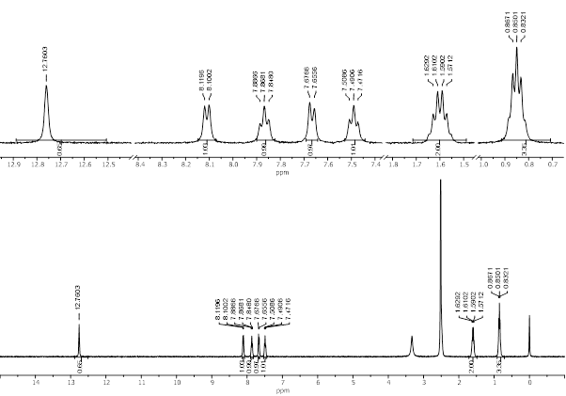
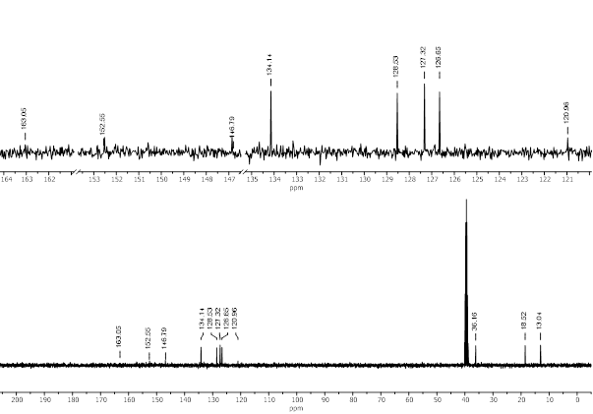
Figure 23 ¹H NMR and ¹³C NMR of 2-propylquinazolin-4(3H)-one (1w) in DMSO-d₆ at 400 MHz
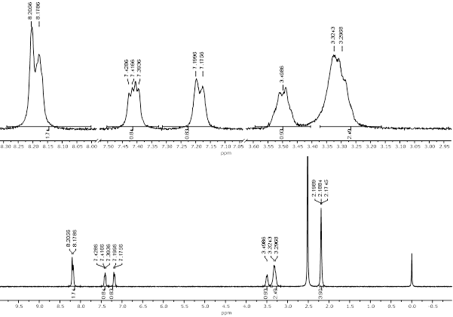
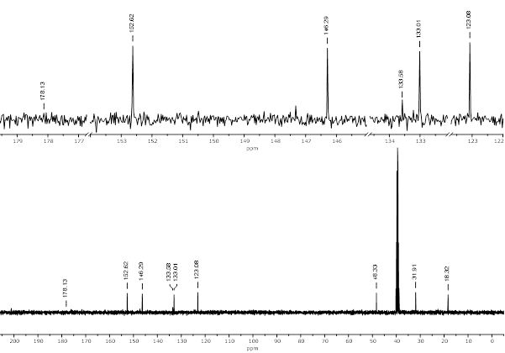
Figure 24 ¹H NMR and ¹³C NMR of 1-(pyridin-3-yl)pyrrolidin-2-one (1x) in DMSO-d₆ at 400 MHz
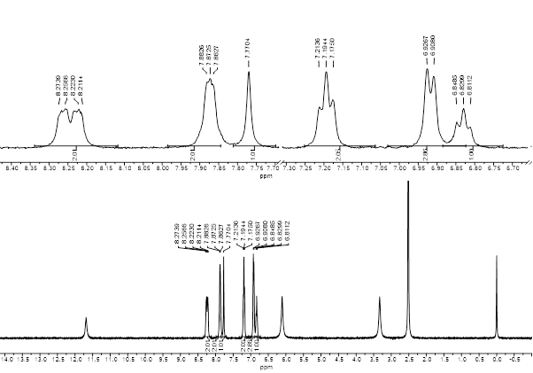
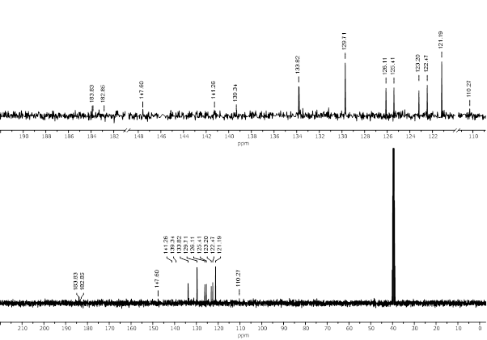
Figure 25 ¹H NMR and ¹³C NMR of 1-amino-9,10-dioxo-4-(phenylamino)-9,10-dihydroanthracene-2-sulfonic acid (2a) in DMSO-d₆ at 400 MHz
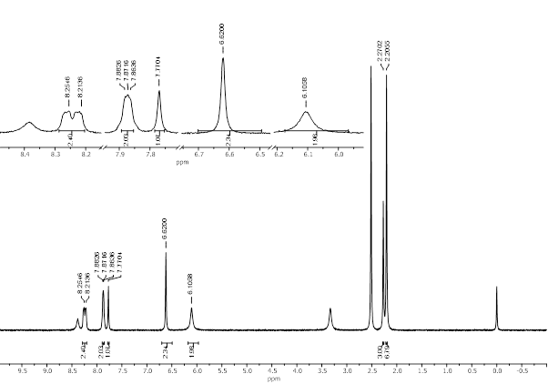
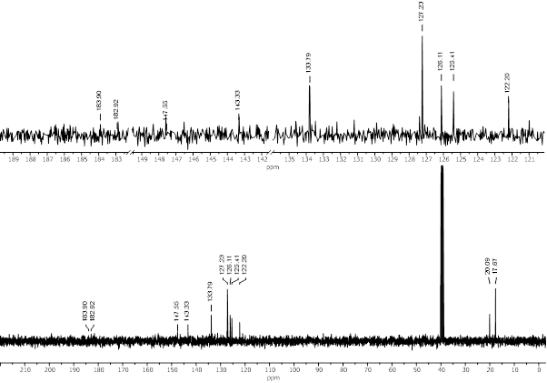
Figure 26 ¹H NMR and ¹³C NMR of 1-amino-4-(mesitylamino)-9,10-dioxo-9,10-dihydroanthracene-2-sulfonic acid (2b) in DMSO-d₆ at 400 MHz
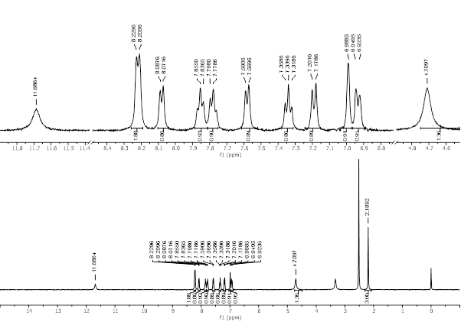
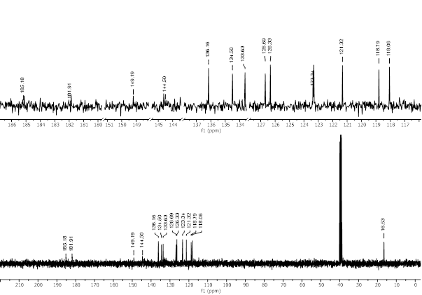
Figure 27 ¹H NMR and ¹³C NMR of 1-((4-amino-3-methylphenyl)amino)anthracene-9,10-dione (2c) in DMSO-d₆ at 400 MHz
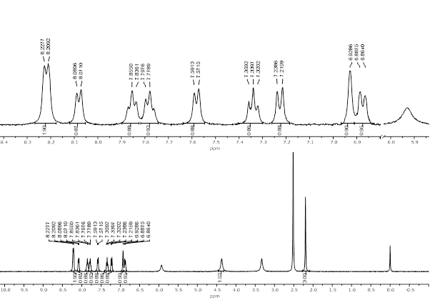
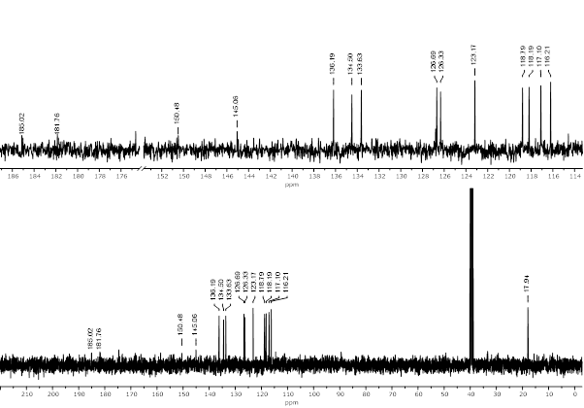
Figure 28 ¹H NMR and ¹³C NMR of 1-((4-amino-2-methylphenyl)amino)anthracene-9,10-dione (2d) in DMSO-d₆ at 400 MHz
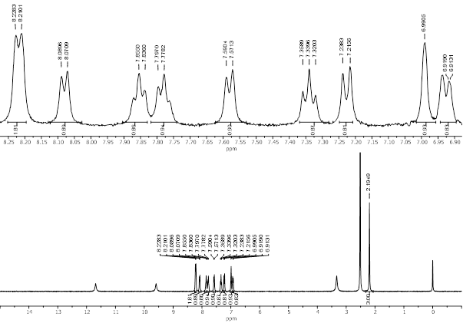
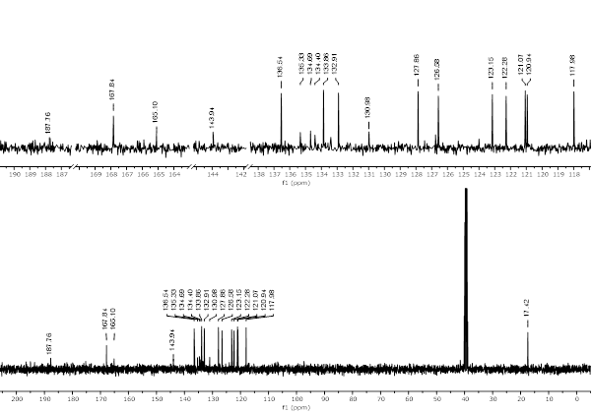
Figure 29 ¹H NMR and ¹³C NMR of 1-((4-((4,6-dichloro-1,3,5-triazin-2-yl)amino)-3-methylphenyl)amino)anthracene-9,10-dione (2g) in DMSO-d₆ at 400 MHz

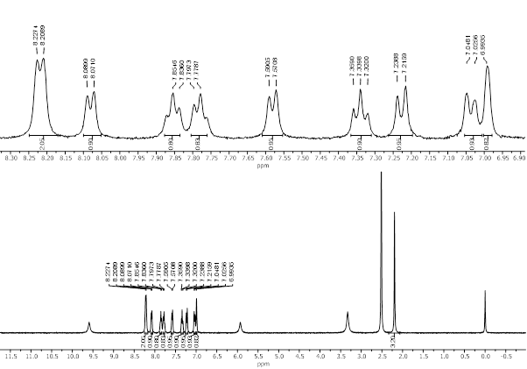
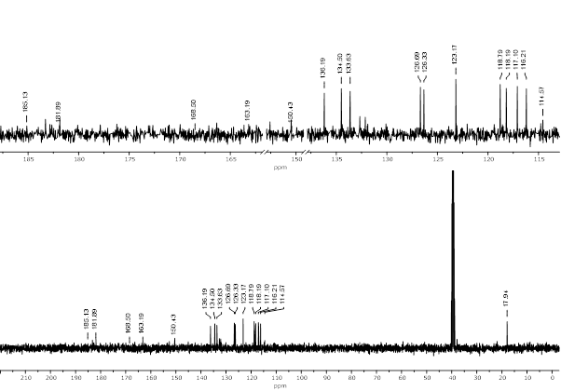
Figure 30 ¹H NMR and ¹³C NMR of 1-((4-((4,6-dichloro-1,3,5-triazin-2-yl)amino)-2-methylphenyl)amino)anthracene-9,10-dione (2h) in DMSO-d₆ at 400 MHz

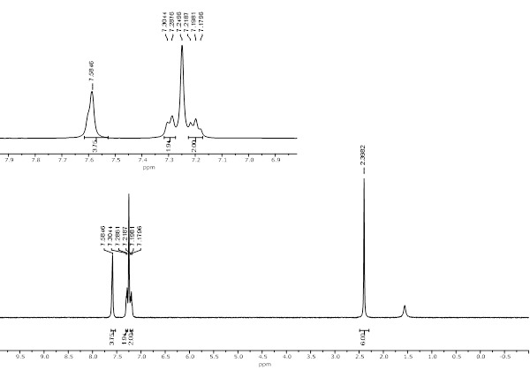
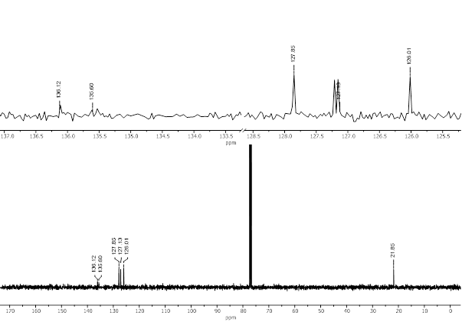
Figure 31 ¹H NMR and ¹³C NMR of 3, 3'-dimethyl-1, 1'-biphenyl (5a) in CDCl₃ at 400 MHz
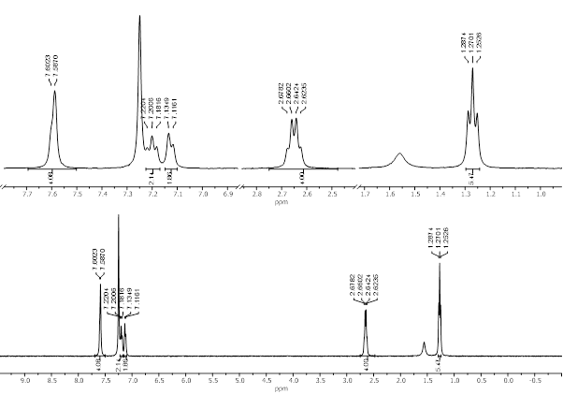
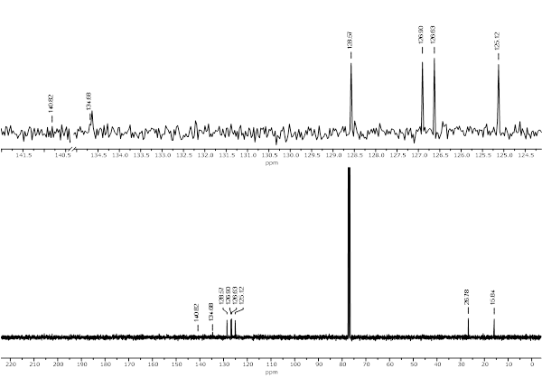
Figure 32 ¹H NMR and ¹³C NMR of 3, 3'-diethyl-1, 1'-biphenyl (5b) in CDCl₃ at 400 MHz
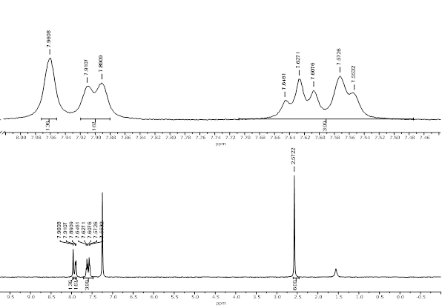
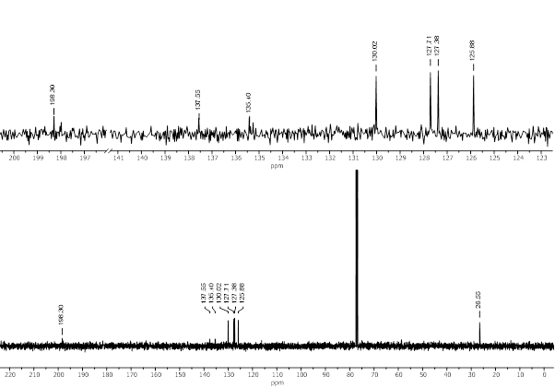
Figure 33 ¹H NMR and ¹³C NMR of 1, 1'-([1, 1'-biphenyl]-3, 3'-diyl)bis(ethan-1-one)(5c) in CDCl₃ at 400 MHz
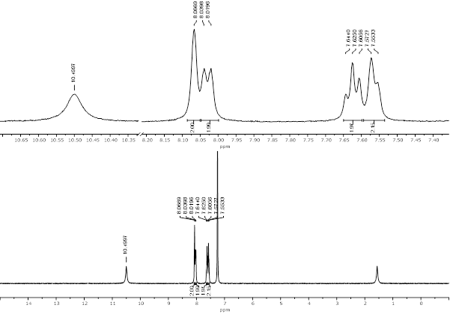
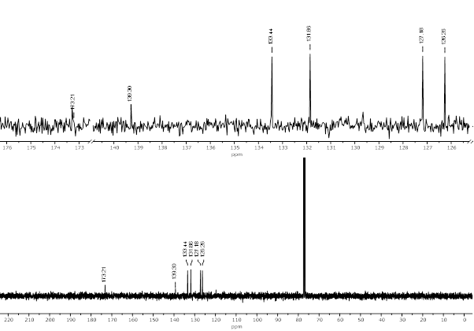
Figure 34 ¹H NMR and ¹³C NMR of [1, 1'-biphenyl]-3, 3'-dicarboxylic acid (5d) in CDCl₃ at 400 MHz

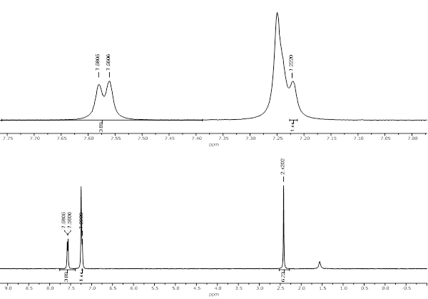
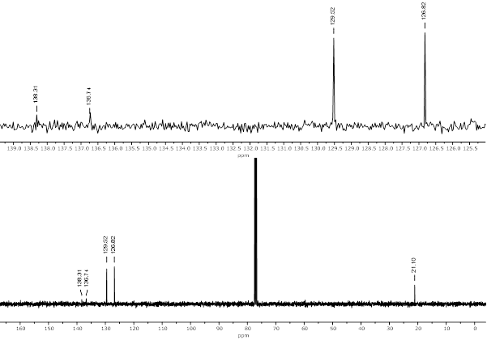
Figure 35 ¹H NMR and ¹³C NMR of 4, 4'-dimethyl-1, 1'-biphenyl (5e) in CDCl₃ at 400 MHz
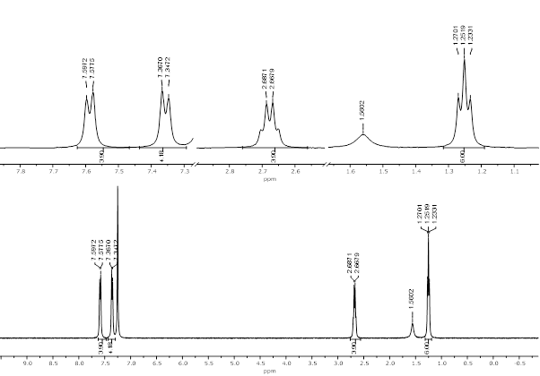
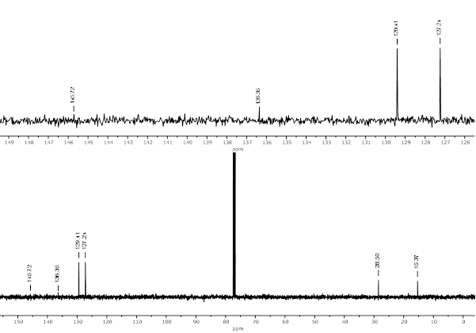
Figure 36 ¹H NMR and ¹³C NMR of 4, 4'-diethyl-1, 1'-biphenyl (5f) in CDCl₃ at 400 MHz
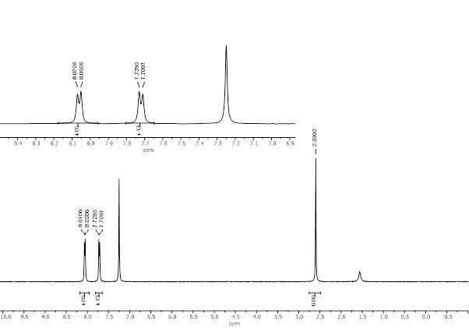
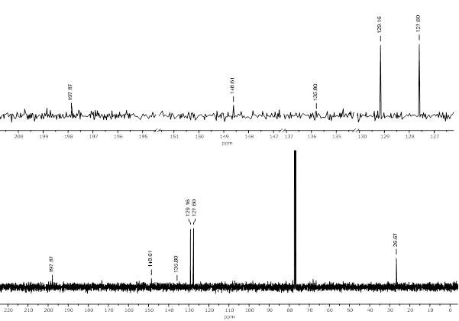
Figure 37 ¹H NMR and ¹³C NMR of 1, 1'-([1, 1'-biphenyl]-4, 4'-diyl)bis(ethan-1-one) (5g) in CDCl₃ at 400 MHz
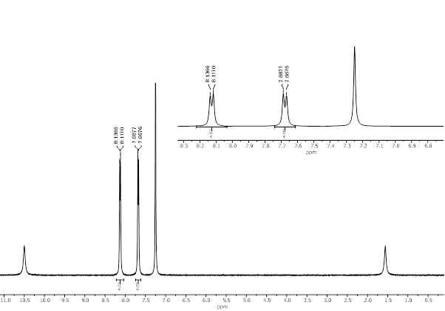
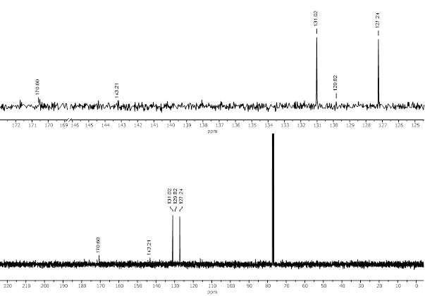 Figure 38 ¹H NMR and ¹³C NMR of [1, 1'-biphenyl]-4, 4'-dicarboxylic acid (5h) in CDCl₃ at 400 MHz
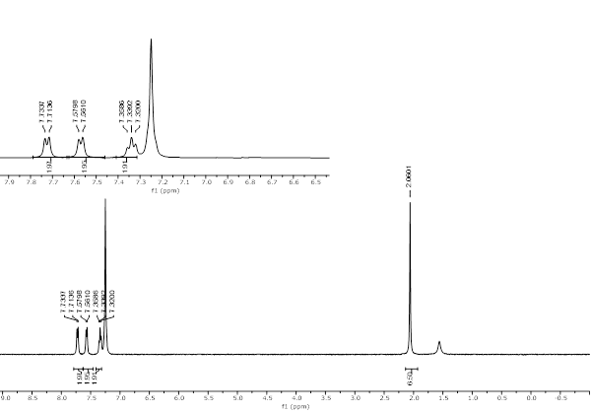
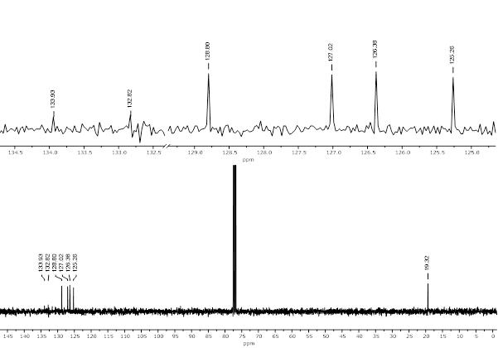
Figure 39 ¹H NMR and ¹³C NMR of 2, 2'-dimethyl-1, 1'-biphenyl (5i)in CDCl₃ at 400 MHz
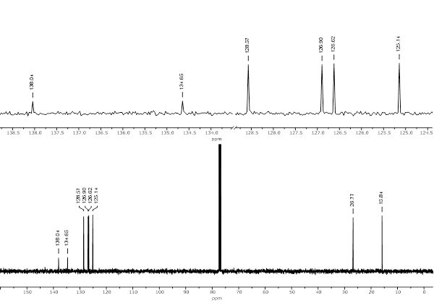
Figure 40 ¹H NMR and ¹³C NMR of 4, 4'-diethyl-1, 1'-biphenyl (5j) in CDCl₃ at 400 MHz
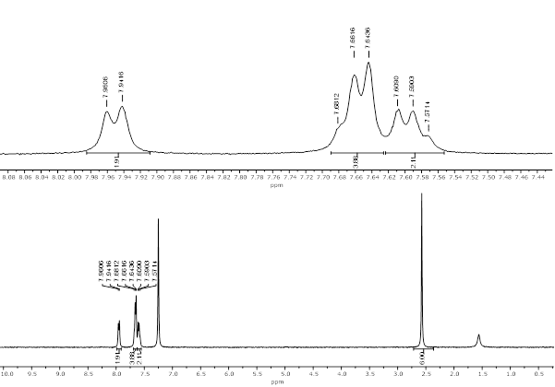
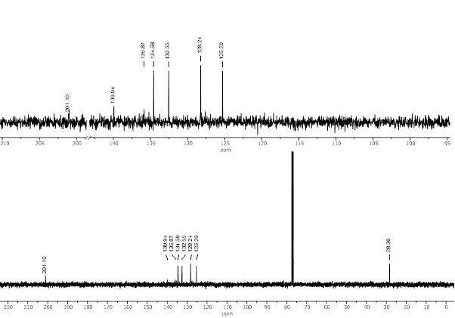
Figure 41 ¹H NMR and ¹³C NMR of 1, 1'-([1, 1'-biphenyl]-2, 2'-diyl)bis(ethan-1-one) (5k) in CDCl₃ at 400 MHz
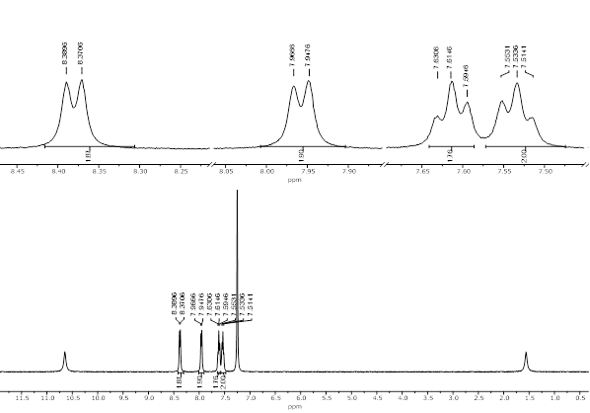
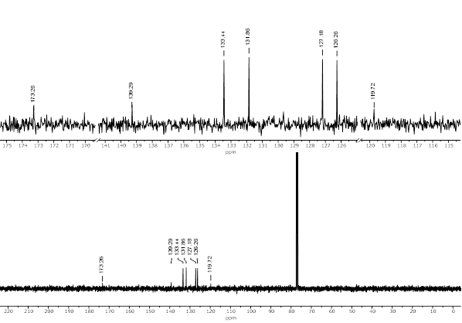
Figure 42 ¹H NMR and ¹³C NMR of [1, 1'-biphenyl]-2, 2'-dicarboxylic acid (5l) in CDCl₃ at 400 MHz
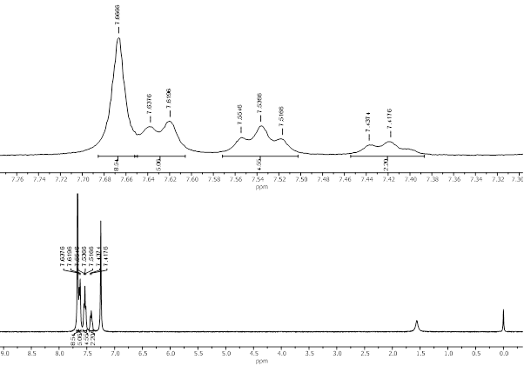
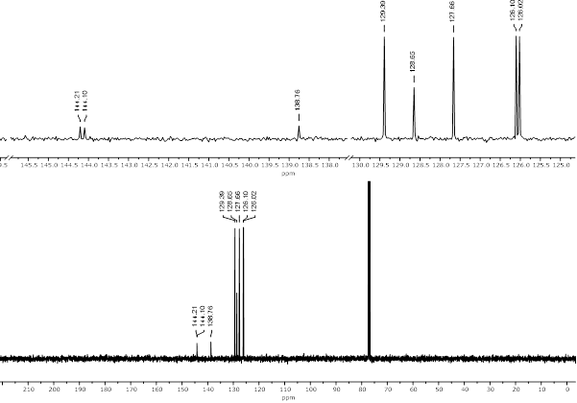
Figure 43 ¹H NMR and ¹³C NMR of 1, 1':4', 1'':4'', 1'''-quaterphenyl (5m ) in CDCl₃ at 400 MHz
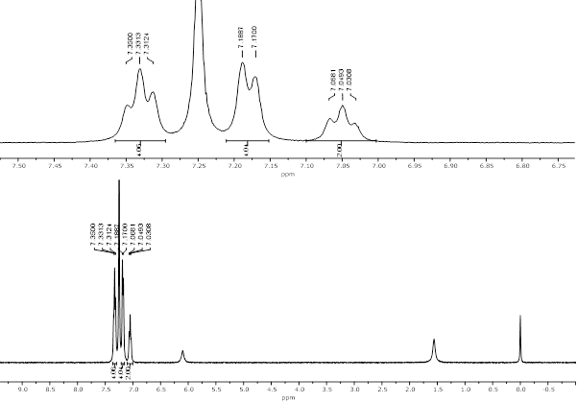
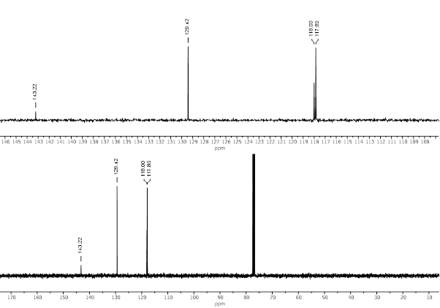
Figure 44 ¹H NMR and ¹³C NMR of Diphenylamine(4a) in CDCl₃ at 400 MHz
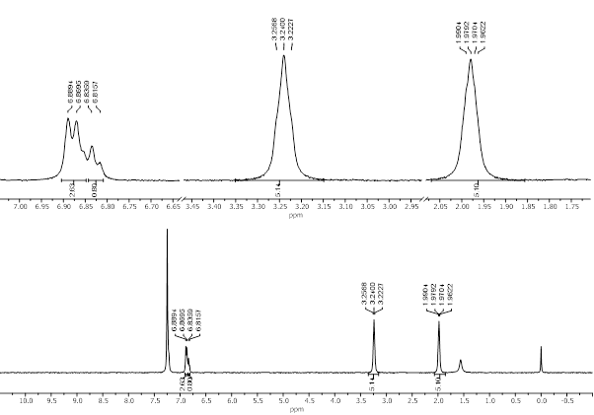
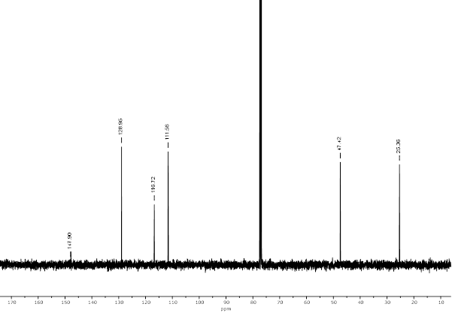
Figure 45 ¹H NMR and ¹³C NMR of 1-phenylpyrrolidine(4b) in CDCl₃ at 400 MHz
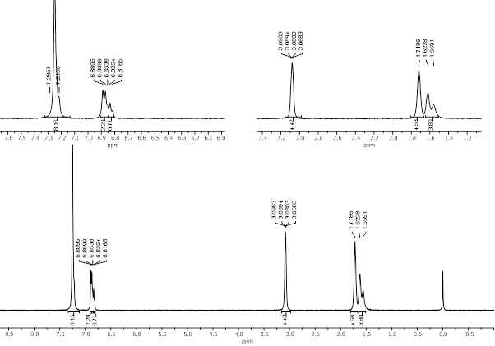
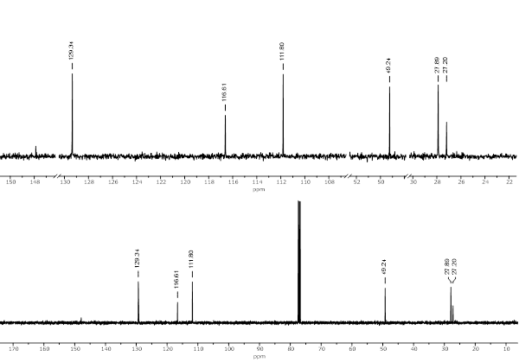
Figure 46 ¹H NMR and ¹³C NMR of 1-phenylpiperidine (4c) in CDCl₃ at 400 MHz
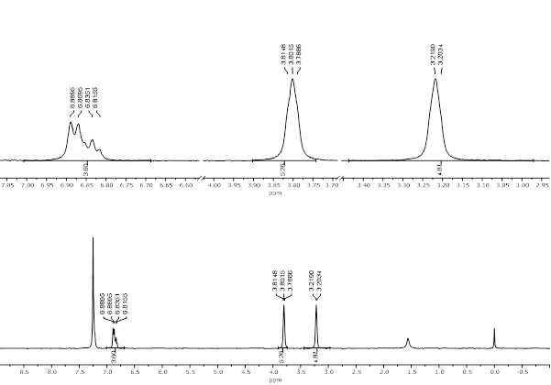
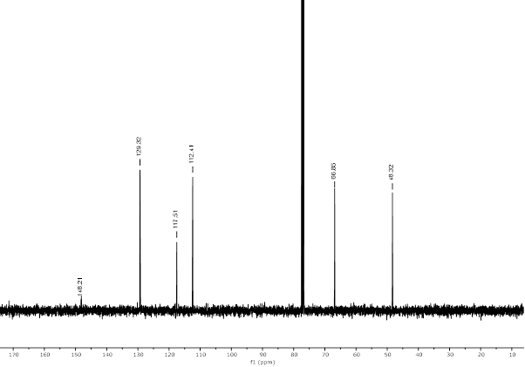
Figure 47 ¹H NMR and ¹³C NMR of 4-phenylmorpholine (4d) in CDCl₃ at 400 MHz
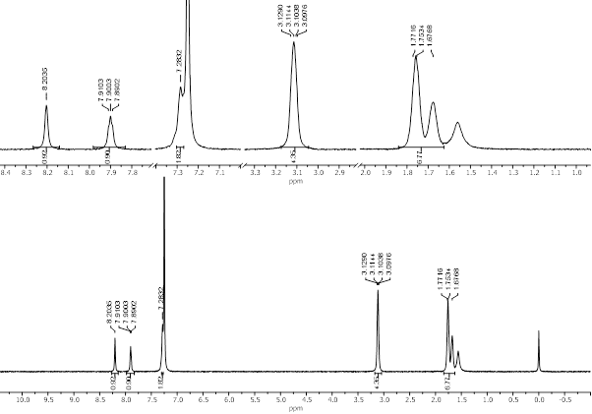
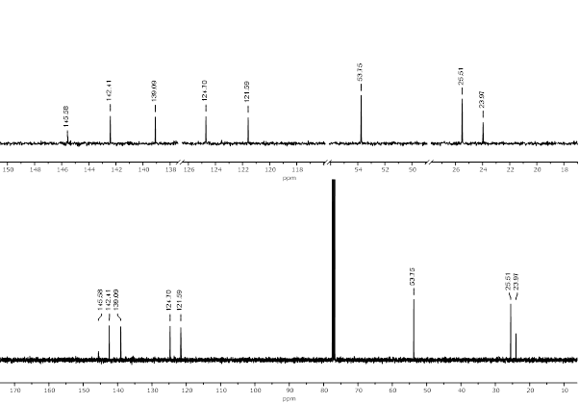
Figure 48 ¹H NMR and ¹³C NMR of 3-(piperidin-1-yl) pyridine (4e) in CDCl₃ at 400 MHz

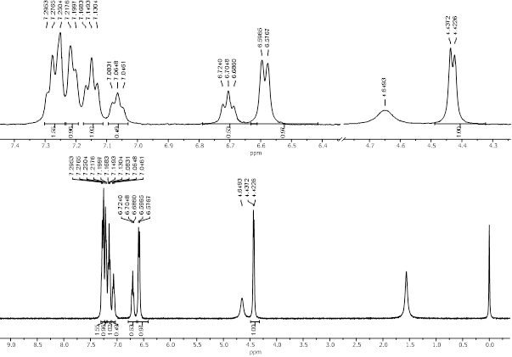
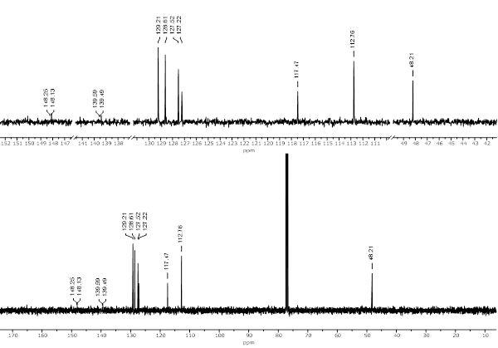
Figure 49 ¹H NMR and ¹³C NMR of N-benzyl aniline (4f) in CDCl₃ at 400 MHz
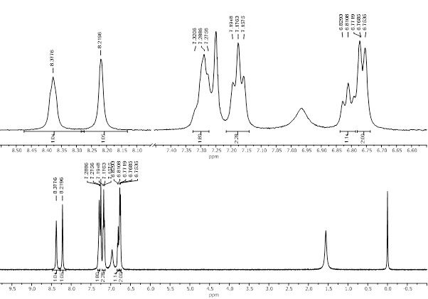
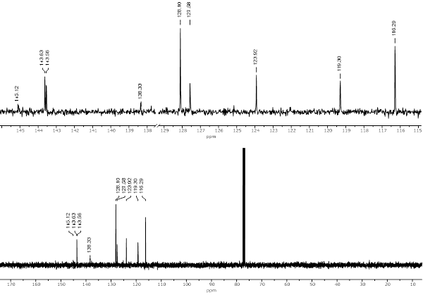
Figure 50 ¹H NMR and ¹³C NMR of N-phenylpyridin-3-amine (4g) in CDCl₃ at 400 MHz
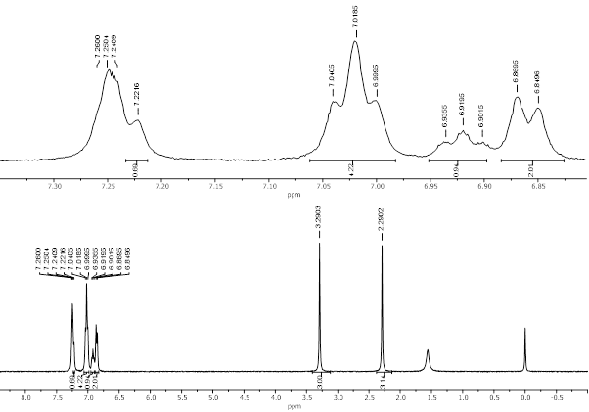
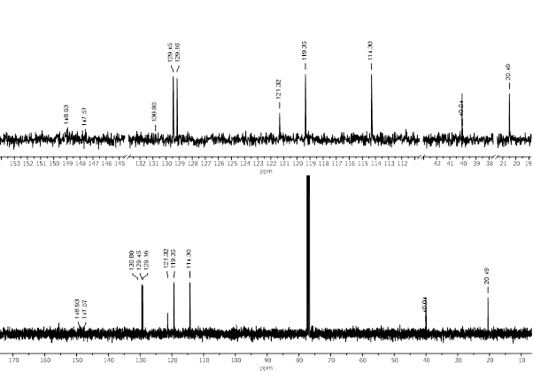
Figure 51 ¹H NMR and ¹³C NMR of N, 4-dimethyl-N-phenylaniline (4h) in CDCl₃ at 400 MHz
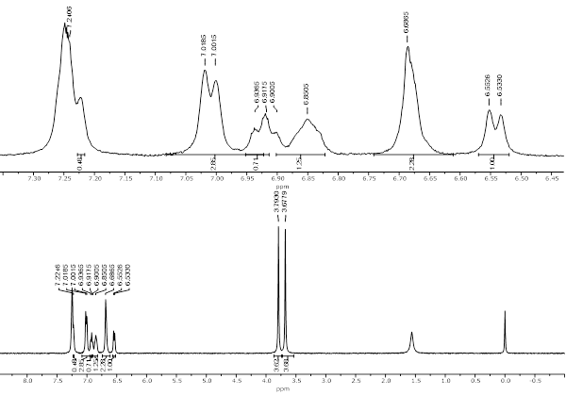
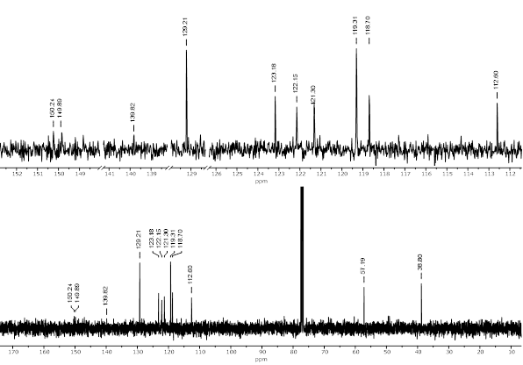
Figure 52 ¹H NMR and ¹³C NMR of 2-methoxy-N-methyl-N-phenylaniline (4i) in CDCl₃ at 400 MHz
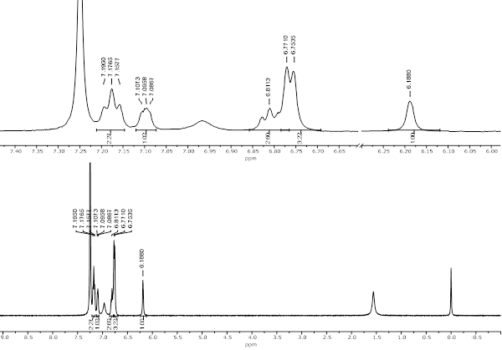
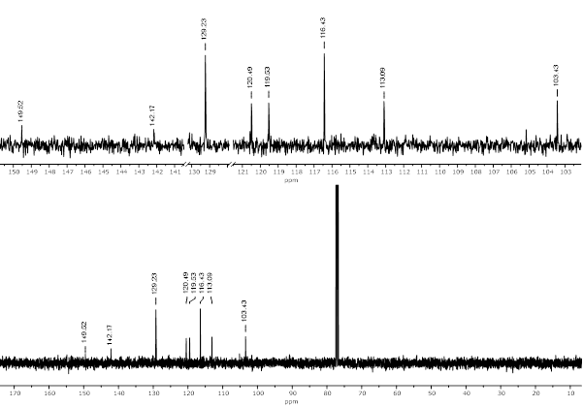
Figure 53 ¹H NMR and ¹³C NMR of N-phenylthiophen-3-amine (4j) in CDCl₃ at 400 MHz
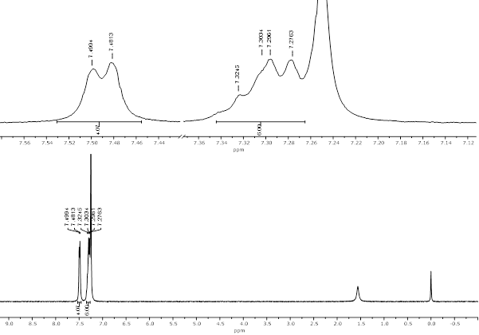
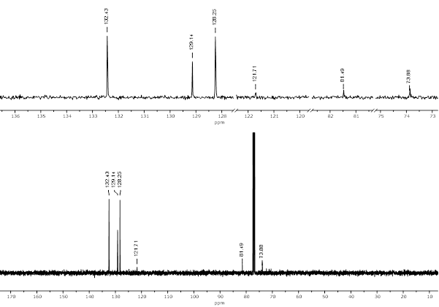
Figure 54 ¹H NMR and ¹³C NMR of 1, 4-diphenylbuta-1, 3-diyne (3a) in CDCl₃ at 400 MHz
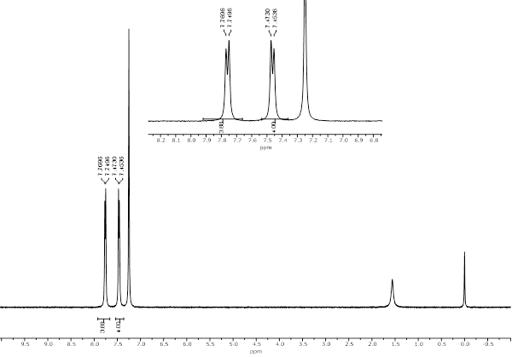
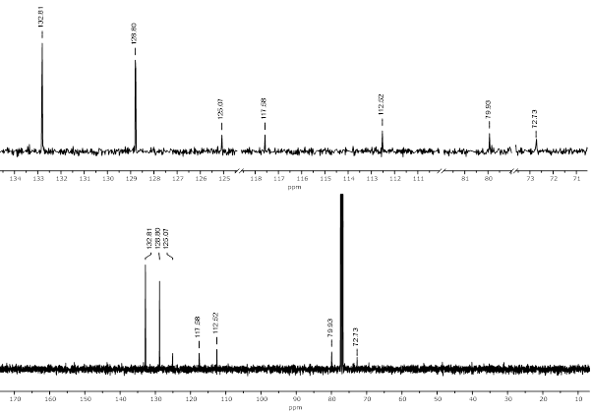
Figure 55 ¹H NMR and ¹³C NMR of 4, 4'-(buta-1, 3-diyne-1, 4-diyl)dibenzonitrile (3b) in CDCl₃ at 400 MHz
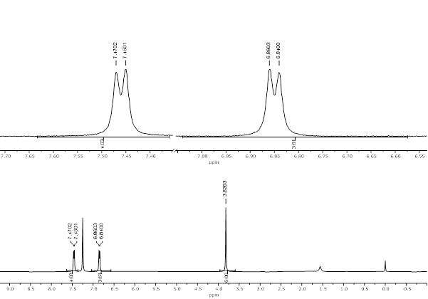
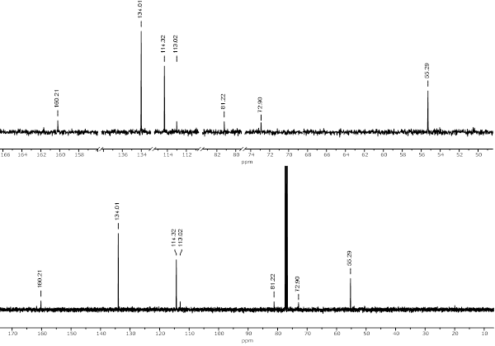
Figure 56 ¹H NMR and ¹³C NMR of 1, 4-bis(4-methoxyphenyl)buta-1, 3-diyne (3c) in CDCl₃ at 400 MHz
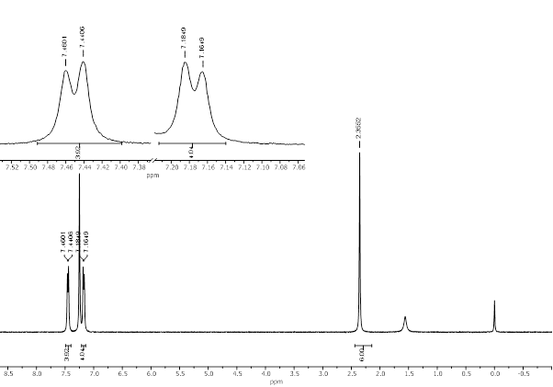
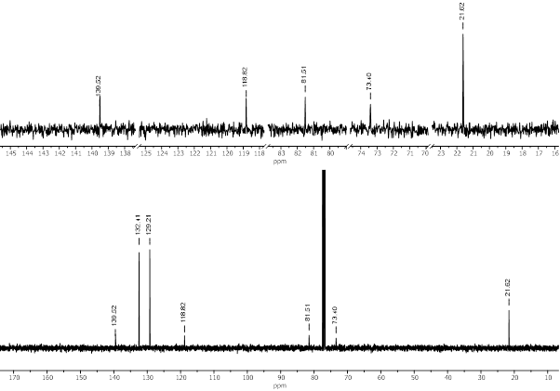
Figure 57 ¹H NMR and ¹³C NMR of 1, 4-di-p-tolylbuta-1, 3-diyne (3d) in CDCl₃ at 400 MHz
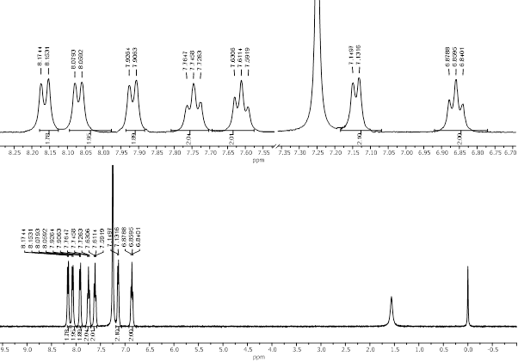
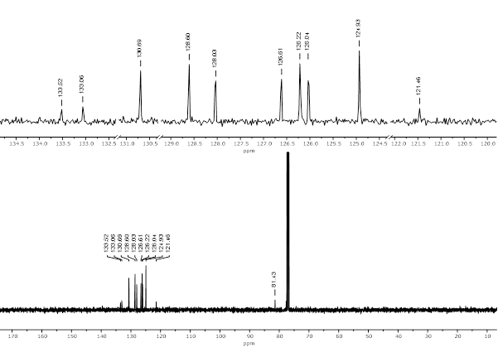
Figure 58 ¹H NMR and ¹³C NMR of 1, 4-di(naphthalen-1-yl)buta-1, 3-diyne (3e) in CDCl₃ at 400 MHz

